Species Condition Index (SCI)

What is the Species Condition Index?

One sentence:

An index which assesses and classifies HUC 12 watersheds for aquatics species richness in the Middle Southeast by Species of Greatest Conservation Need (SGCN) counts.

A little more detail:

The Species Condition Index (SCI) is a product of the 2021 Middle Southeast Blueprint. The SCI evaluates HUC-12 watersheds in the Middle Southeast to determine the aquatic species richness and informs broad species diversity in the watershed. The species model complements the aquatic habitat models of the Streams and Rivers Condition Index (SRCI) and the Big Rivers Condition Index (BRCI). Watersheds are scored 0-4 based on the SGCN present in the given watershed. (0 = 0 species present, 1 = 1 species present, 2 = 2 species present, 3 = 3 species present, 4 = 4 or more species present)

What data are being used to evaluate the watershed indicators? What metrics were developed for the indicators?

The Species Condition Index is scaled to the HUC-12 watershed level. It is a standardized species richness index using data derived from the Southern Aquatic Resource Partnership (SARP):

* **SARP SGCN Index: This index includes aquatic SGCN in the region in addition to EnviroAtlas data, produced by the US Environmental Protection Agency, to capture plants and crayfish that were not included in previous versions of this index. Data is derived from a data sharing agreement between SARP and the southeastern state wildlife agencies.**

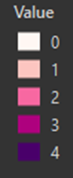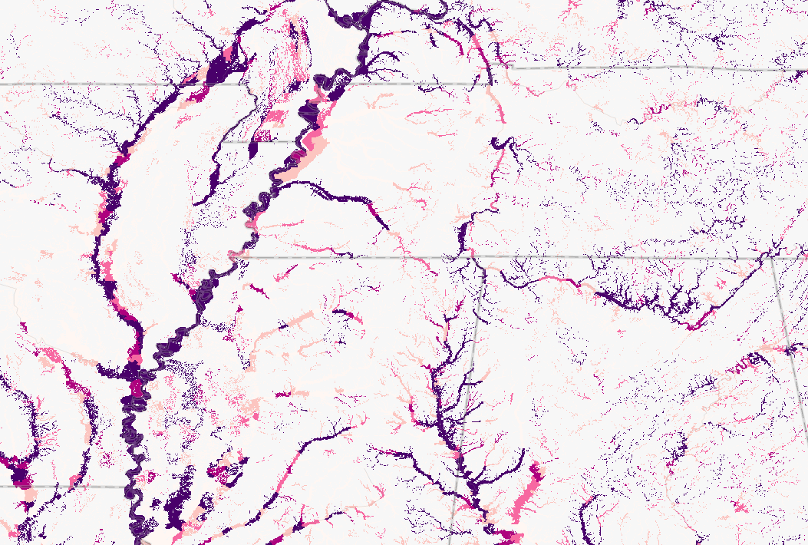What does the final output look like?

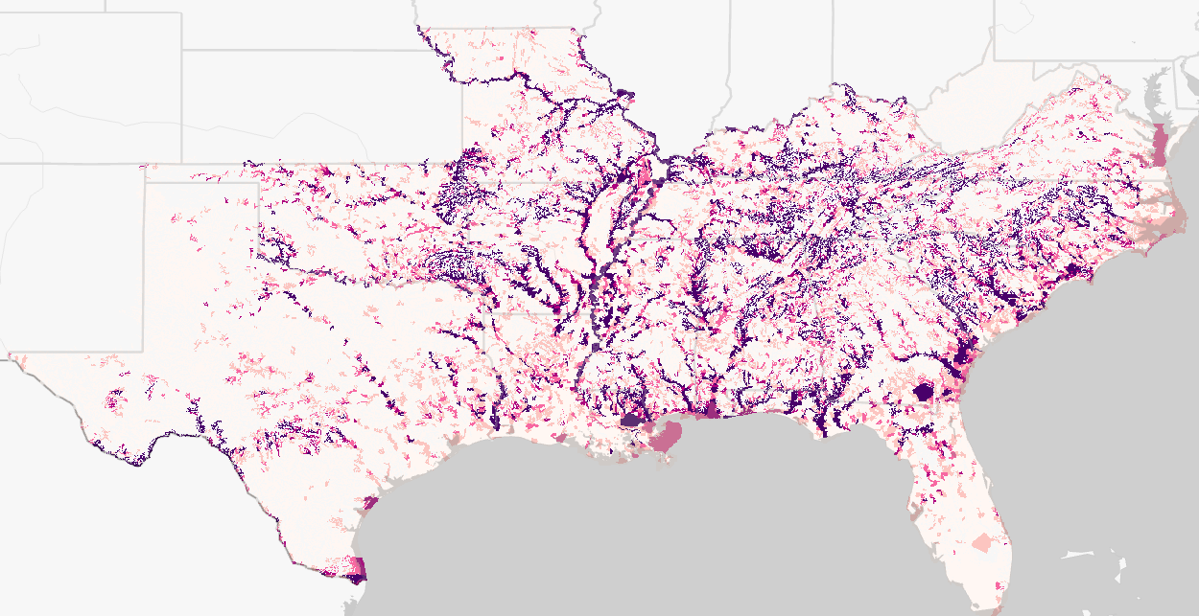

The final output is a spatial dataset that scores watersheds in the southeastern United States based on species richness of SGCN species, masked to EPA Floodplains.

Caveats?

* Holes in the input dataset

How is this tool being used? How can it be used?

The tool is being incorporated into the 2021 Middle Southeast Blueprint update. It will help guide development of the overall Southeast Blueprint. The goal of Southeast Blueprint is a connected network of lands and waters throughout the southeast which supports thriving fish and wildlife populations and improved quality of life for the people in the geography. This tool will help in identifying the connected network.

This tool was developed to help support management decisions as well. The tool can help prioritize resources (funding, personnel, etc.) depending on the management action desired: species-level restoration, enhancement, or maintenance. Further, it can help identify larger regions which have potential to support aquatic species restoration efforts in the future, ex: SCGN recovery efforts. It can also be used in conjunction with the Streams and Rivers Condition Index and Big Rivers condition Index for a full picture of aquatic resources in the region.

Where does the Species Condition Index fit in the 2021 Middle Southeast Blueprint?

Filed Under: Mid Southeast BP Update> Aquatics > Species > Species Condition Index